GLOBAL ACADEMY

CLASS -1

SESSION 2025-26

WORKSHEET- ENGLISH

Q1. Add the missing letters

1. A f________n keeps up cool in summer (I or a)

2. I see little tiger c__ bs at the Zoo (a or u).

3. Ice cream will m_lt in the sun. (U or e).

Q2. Unscramble the letter:

1. PHSI ______________________
2. ROEHS _____________________ 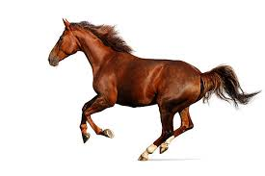
3. CTISK _______________________ 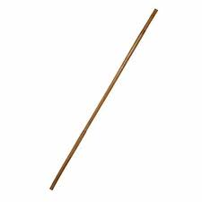

Q3. Write the rhyming words:

Cake Ride

m______ s_________

r_________ w________

s________ h_________

Q4. Fill in the blanks with vowel : ( a,e,I,o,u)

S_ nd_y

m_nd_y

fr_d_y

w_dn_sd_y

Q5. Write the missing alphabet

a_______cd________f_______h__________k______m n o p ___ _______ s ________ u__________w x___________ ___________

Q6. Compound words

1. Sun + flower = Sunflower
2. Rain + coat =_____________
3. Foot+ ball =_____________
4. Lunch + box=__________

Q7. Match the following

Good Out

In Bad

Come far

Near go